**IS420 Homework 2**

**Due: 4/04/2018 11:59PM**

**What you need to submit in your assignment document (MS Word or PDF):**

**For every question submit:**

**1. SQL query/ PLSQL program unit**

**2. SCREENSHOT OF THE OUTPUT (wrong screenshots or missing screenshots will result in deduction of 50% of the points)**

Once your homework is graded please check the grades and let the TA know if there are any discrepancies within one week.

1-(25 points) related topics :view, predefined_functions group by.

Create a **view** that contains statistics readings for invoices total in each state. This view is important for the decision makers. The view contains one row per state and contains seven columns (vendor_state, total_sum_invoices, average, median_value, mode_value, max_value, min_value)

The columns description as follow:

* Vendor_state: vendor_state from vendors table
* Total_sum_invoices: is the SUM of all invoice_total for each state. Use SUM() function
* Average : is the average of all invoice_total for each state. Use AVG() function and round the result using ROUND() function.
* Median_value: is the middle value of invoice_total for all invoice_total for each state. Use MEDIAN() function
* Mode_value: is the most frequent invoice_total value for each state. Use STATS_MODE() function
* Max_value: is the maximum invoice_total for each state. USE MAX() function.
* Min_value: is the minimum invoice_total for each state. USE MIN() function.

Submit the following :

* The code to create the view
* A screenshot to show the data in the view.

“create or replace view state_view

as

select vendor_state,

sum(invoice_total) as invoice_sum, round(avg(invoice_total)) as invoice_avg,

median(invoice_total) as invoice_median, stats_mode(invoice_total) as invoice_mode,

max(invoice_total) as invoice_max, min(invoice_total) as invoice_min

from vendors, invoices

where vendors.vendor_id = invoices.vendor_id

group by vendor_state;”

“select * from state_view;”

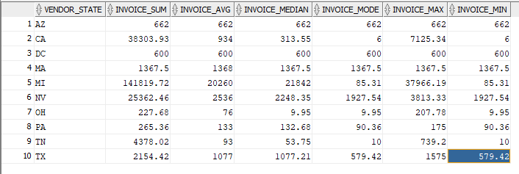

2-(25 points) related topics :view, predefined_functions, group by.

Create a **view** that list all vendors names and the average_months_between the invoice_due_date and the invoice_date. Round the “average_months_between” to one decimal point e.g. (99.9). Filter your results to only show those vendors that the “average_months_between” is greater than or equal 1.5 months. Then, sort the result set in descending order by the average_months_between.

Hint: the round of 12.567 to one decimal point can be obtained using ROUND(12.567,1) = 12.6

Submit the following:

* The code to create the view
* A screenshot to show the data in the view.

“create or replace view Average_Months

as

select vendor_name, round(avg(months_between(invoice_due_date, invoice_date)),1) as average_months_between

from vendors, invoices

where vendors.vendor_id = invoices.vendor_id

and 1.5 <= (select round(avg(months_between(invoice_due_date, invoice_date)),1) from invoices where invoices.vendor_id = vendors.vendor_id)

group by vendor_name

order by average_months_between desc;”

“select * from average_months”

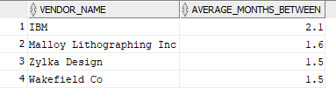

3-(25 points) related topics : anonymous block program unit, implicit cursor, bind_variables, user_defined_exception.

Write an **anonymous block program unit** that display the number of invoices in invoices table for a specific state which is entered by the user (bind variable). The number of invoices should be only for those invoices that are due ( payment_date= null) and its invoice total exceeds $500 (like >$500). The printed message should be like **" # invoices in the state of % are due and exceed $500 dollars"** where # is 'count value' and the % is the user-input state.

You will define an exception called 'ZERO_COUNT'. The program raises the exception"ZERO_COUNT" if the count of invoices retrieved =0. and print the message **"No invoices that are due and exceeds $500 were found for the state of %"** where % is to be replaced with the user-input state.

Hint:

* Use implicit cursor only.
* Do not use "no_data_found" exception. It will not be triggered if you used it
* Declare only one variable to hold the count and one exception called "ZERO_COUNT"

Try three cases:

State: “CA”

State: “MD”

State: “MI”

Submit the following:

* The code to create the program
* A screenshot to show the message for each test case.

“set serveroutput on;

declare

no_data exception;

bind char(2);

ct number;

begin

bind := :bind;

select count(invoice_id) into ct

from invoices , vendors

where vendor_state = bind

and invoices.vendor_id = vendors.vendor_id

and payment_date is null

and invoice_total > 500;

if ct > 0 then

dbms_output.put_line(ct || ' invoices in the state of ' || bind ||' are due and exceed $500 dollar');

else

raise no_data;

end if;

exception when no_data then

dbms_output.put_line('No invoices that are due and exceeds $500 were found for the state of ' || bind);

end;”

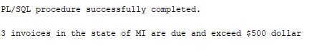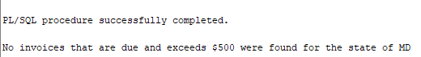

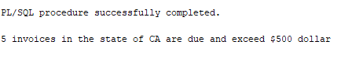

4-(25 points) related topics : anonymous block program unit, explicit cursor, bind_variable, reference variable rowtype, iterative logic , Exceptions.

Write an **anonymous block program unit** that display vendors names, full address (address1-city-state-zipcode) for those vendors who live in a user-input city.

Try two cases (**case sensitive**):

City: Chicago

City: Washington

Submit the following:

* The code to create the program
* A screenshot to show the results for each test case.

“set serveroutput on;

declare

no_city exception;

city varchar(30) := :city;

ct number := 0;

cursor vendor_cursor is

select vendor_name, vendor_address1, vendor_address2, vendor_city, vendor_state, vendor_zip_code

from vendors

where vendor_city = city;

vendor_row vendor_cursor%rowtype;

begin

for vendor_row in vendor_cursor

loop

dbms_output.put_line('Vendor Name: ' || vendor_row.vendor_name ||

' Vendor Address: ' || vendor_row.vendor_address1 || '

' || vendor_row.vendor_address2 || ' ' || vendor_row.vendor_city || '

' || vendor_row.vendor_state || ' ' || vendor_row.vendor_zip_code);

ct := ct + 1;

end loop;

if ct = 0 then

raise no_city;

end if;

exception when no_city then

dbms_output.put_line('City ' || city || ' not found');

end;”

